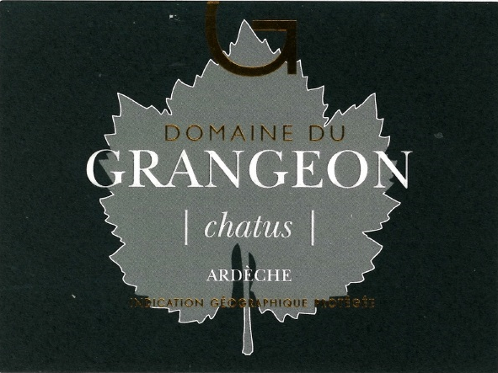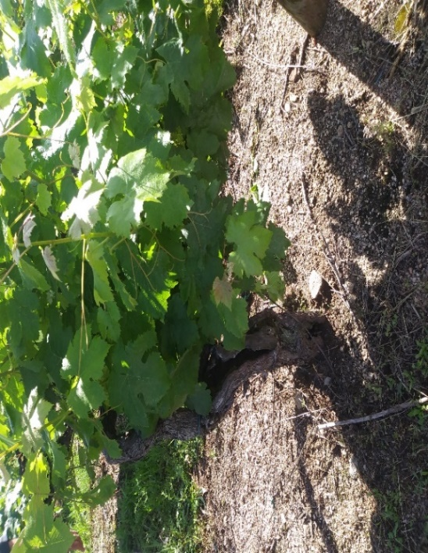

Domaine de Grangeon
Chatus
2020

Grower: Christophe and Christelle Reynourd, one of a select few of the world’s only independent producers and bottles of Chatus.

Grape Varieties: Chatus, pronounced (cha~two), the ancient 12th Century grape variety cultivated only
by a few estates. A relative of an ancient clone of Nebbiolo (Barolo and Barbaresco).

Village: Balbiac
Production: 4,500 bottles.

Soil: Pulverized Granite topsoil, sandstone subsoil.

Vinification: Cultivated entirely by hand. No herbicides or chemical treatments in the vines. Most of chatus’ continued obscurity is due to the highly skilled pruning technique needed to get the vine to bear fruit and the absurdly brief two-day harvesting window when the grapes must be picked. After a full Malolactic fermentation, into new Seguin Moreau Burgundy barrels for 24 months. Bottled by gravity.

Tasting Notes

“Ample, violet-laced blackberry fruits, scorched earth, tar, graphite
and licorice to go with a medium-bodied, structured, yet elegant profile on the palate. The texture is liquid granite, and it flows over the tongue as if woven from the finest silk. Yet this medium-bodied wine is light and graceful, with notable, savory tannin and integrated acidity with cherry, spice and pepper.”

