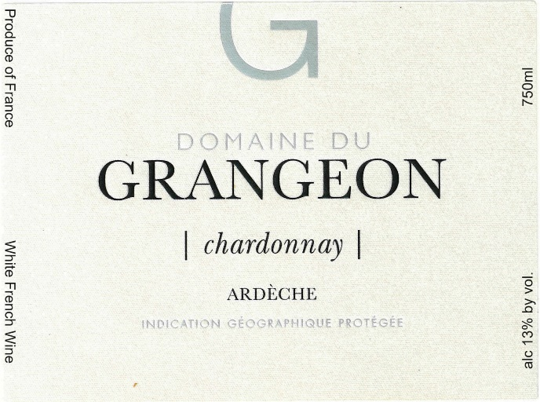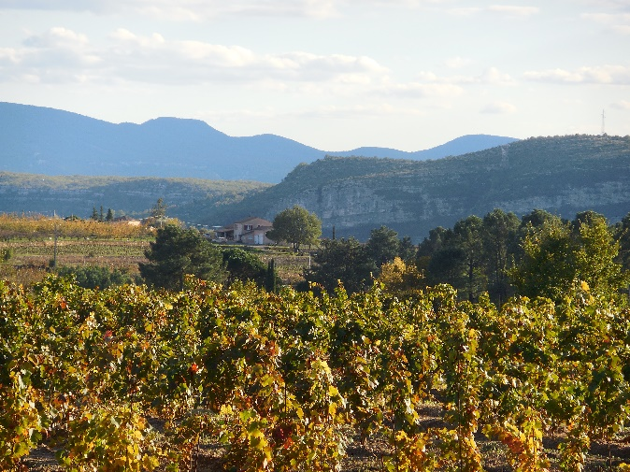

Domaine du Grangeon
Chardonnay 2022

Grower: Christophe and Christelle Reynourd

Grape Varieties: Chardonnay

Village: Balbiac, the western Ardeche.
Production: 4,500 bottles

Soil: Pulverized Granite topsoil, sandstone subsoil.

Vinification: A variety of Chardonnay clones. After destemming, grapes are pressed delicately in a pneumatic press. Juice is fermented by indigenous yeast in older French barrels. Aging is from 12 to 16 months in partially-used, 90-liter barrels.

Tasting Notes

Light straw yellow with green highlights. Vibrantly floral, with white peach, minerals and white flowers. Brisk, fresh with acidity, yet opulent and expressive with orchard fruits – acacia, pear and melon – spiced with hints of citrus and an intense stony minerality.

