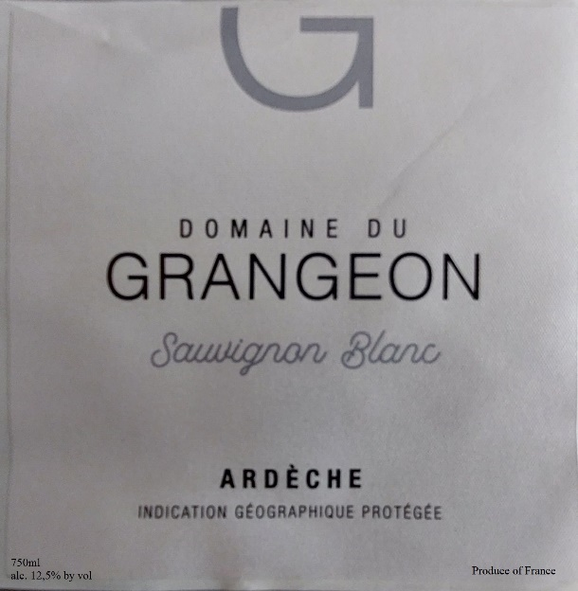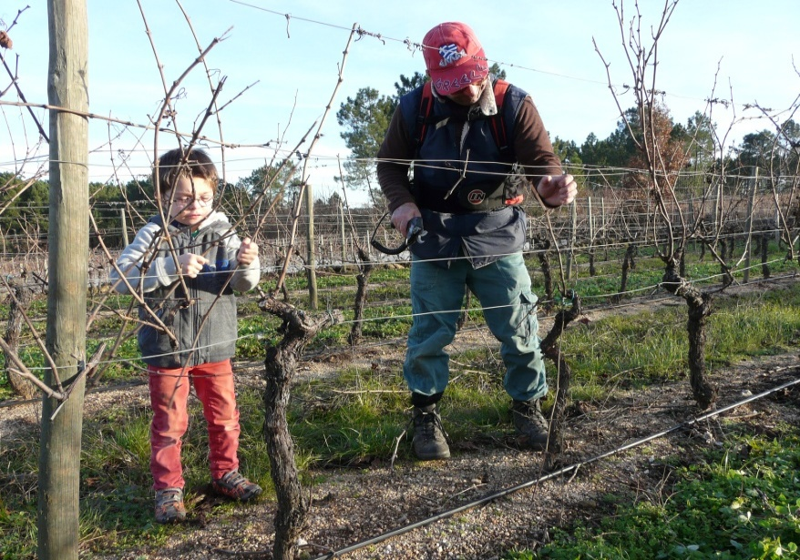

Domaine de Grangeon
2022 Sauvignon Blanc

Grower: Christophe and Christelle Reynourd.

Grape Varieties: Sauvignon Blanc, clonal type 108 for its aromatic complexity
Vines Planted: 1989

Village: Balbiac
Production: 2,000 bottles.

Soil: Pulverized Granite topsoil, sandstone subsoil.

Vinification: Cultivated entirely by hand. Christophe completed his viticulture training at the estate of Georges Vernay, the master of Viognier in Condrieu. Here he applies a genteel hand to Sauvignon Blanc. No herbicides or chemical treatments in the vines. Pressing is slow, long and gentle. 20% fermented in new barrels, with full malolactic fermentation for eight months. Bottled by gravity.

Tasting Notes

“Clear light green in color. Rich minerality, with zesty lime notes, framed by stone fruits. Some peach and tropical notes with air. Medium-bodied, yet lithe and racy on the palate. White stone fruits, framed by racy acidity which retains freshness”

