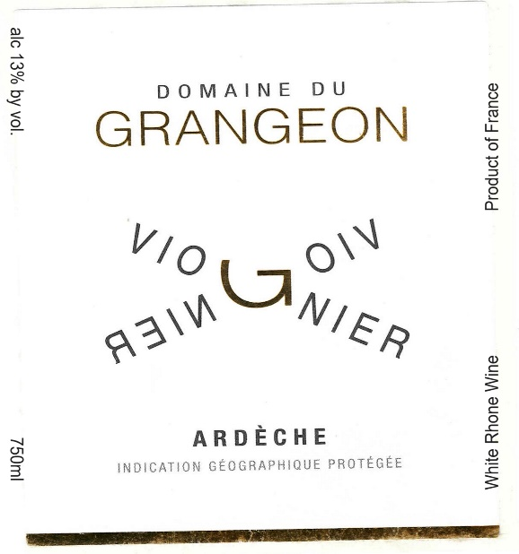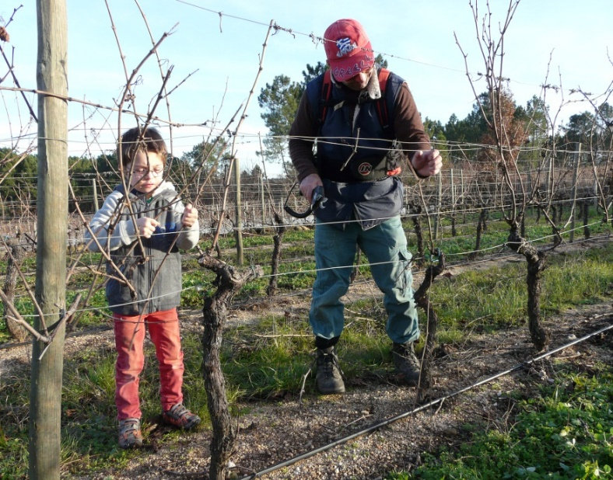

Domaine de Grangeon
Viognier 2023

Grower: Christophe and Christelle Reynourd.

Grape Varieties: Viognier
Planted: 1989

Village: Balbiac
Production: 5,000 bottles.

Soil: Pulverized Granite topsoil, sandstone subsoil.

Vinification: Cultivated entirely by hand. Christophe completed his viticulture training at the estate of Georges Vernay, the master Viognier in Condrieu. No herbicides or chemical treatments in the vines. Pressing is slow, long and gentle. 60% fermented in new barrels, with full malolactic fermentation for eight months. Bottled by gravity.

Tasting Notes

“With minerality is often accompanied by a freshness reminiscent of a sea breeze, sometimes even with hints of mint. Full-bodied, rich in texture, yet fresh. Honey suckle, kiwi, lemon zest and white peach.”

