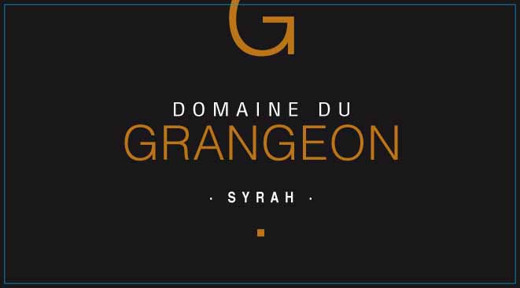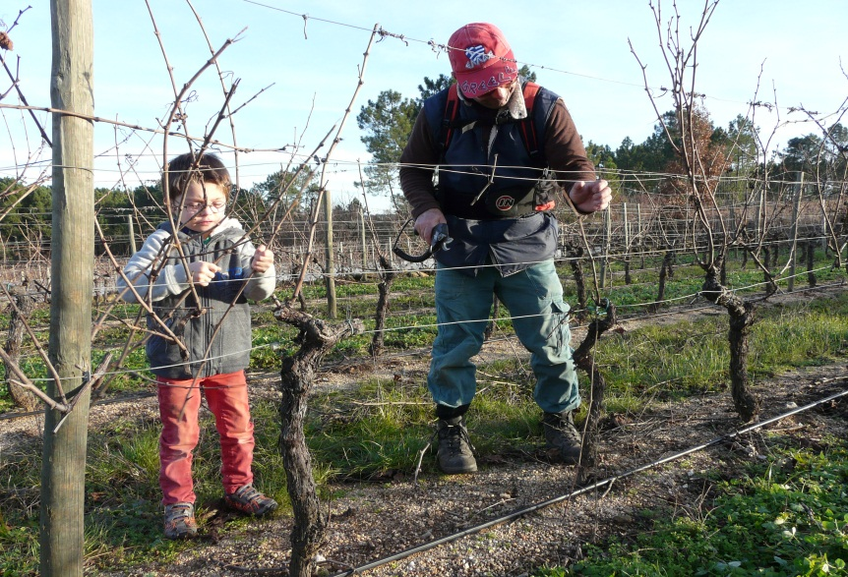

Domaine du Grangeon
Syrah 2023

Grower: Christophe and Christelle Reynourd

Grape Varieties: Syrah

Village: Balbiac
Production: 4,500 bottles

Soil: Pulverized Granite topsoil, sandstone subsoil.

Vinification: Handpicked to ensure only the healthiest and unbroken grapes. Fully destemmed, with fermentation in temperature-controlled stone. Maceration is a long 25 days, with a slow
gentle punching down of the floating cap. Aging is from 18 months in used, 90 liter barrels.

Tasting Notes

“The 2023 Coteaux du l’Ardeche Syrah is beautiful, with northern Rhone-like black pepper, blackberry, violets, olive and hints of bacon fat all emerging from the glass. Medium-bodied, seamless and elegant, with a lightly textured and juicy feel, I don’t think it will make old bones, but it will dish out plenty of pleasure over the coming 3-5 years.”

.

